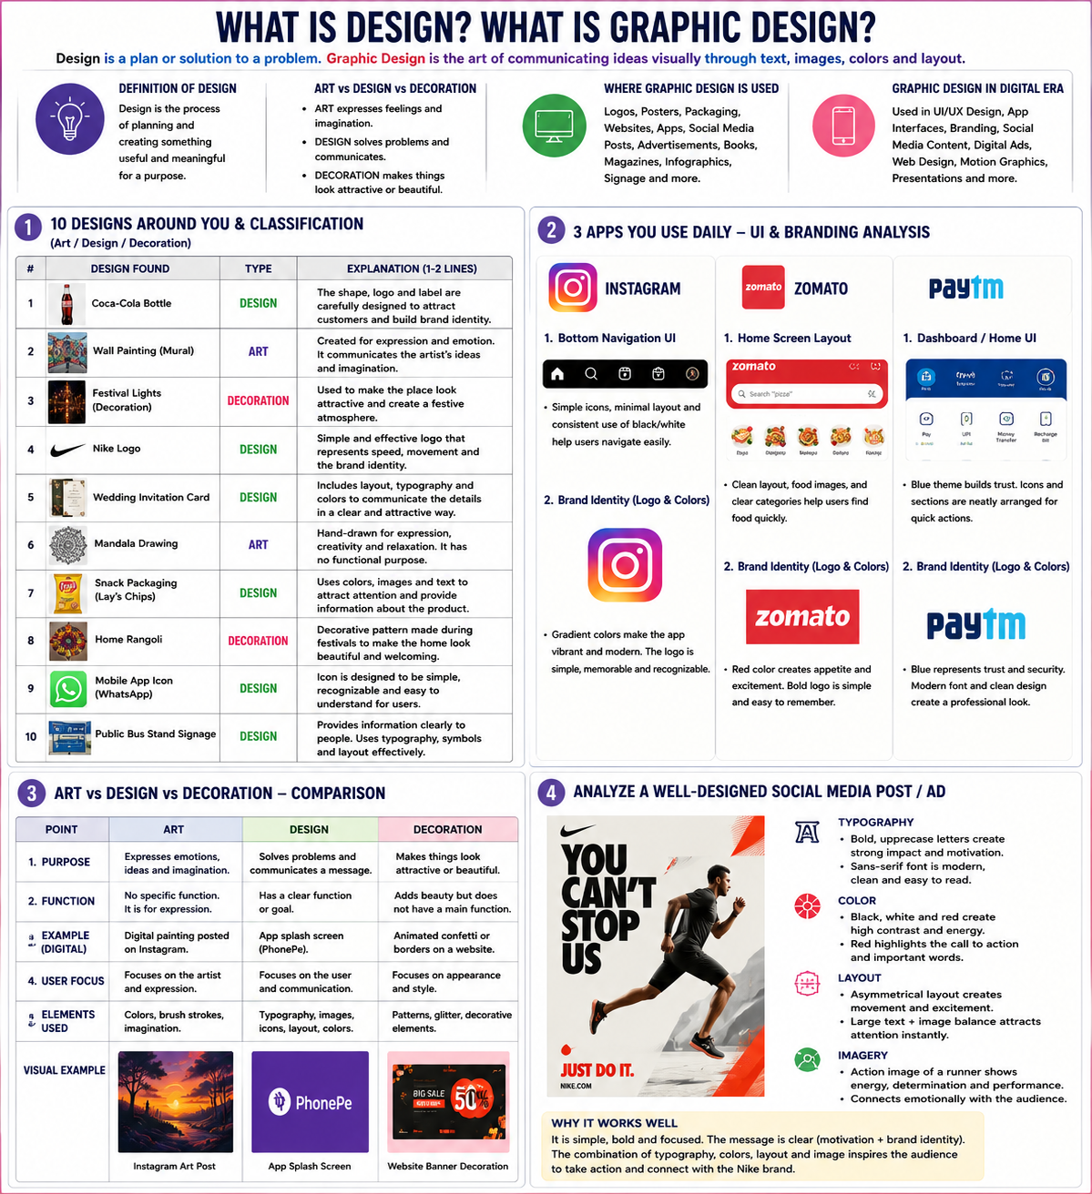Task 1 – 10 Designs Around You & Classification
No. | Design | Type | Explanation
1 | Instagram App | Design | Uses colors, icons, and layout to help users navigate easily.
2 | Coca-Cola Bottle | Design | The bottle shape and logo help customers recognize the brand.
3 | Wall Painting | Art | Created mainly for creativity and self-expression.
4 | Festival Lights | Decoration | Used to make places look attractive during celebrations.
5 | Nike Logo | Design | Represents the brand using a simple and memorable symbol.
6 | Rangoli | Decoration | Made to beautify homes during festivals.
7 | Lay's Chips Packet | Design | Uses graphics and colors to attract customers and provide information.
8 | Mandala Artwork | Art | Focuses on creativity rather than solving a problem.
9 | WhatsApp Icon | Design | Helps users quickly identify the application.
10 | Bus Stop Sign Board | Design | Communicates directions and information clearly.

Task 2 – 3 Apps UI & Branding Analysis
Instagram
UI
- Bottom Navigation Bar – Helps users switch between sections quickly.
- Story Icons – Circular shapes make stories easy to identify.
Branding
- Gradient Logo – Creates a modern and vibrant identity.
- Pink, Purple & Orange Colors – Make the brand energetic and memorable.

Zomato
UI
- Search Bar – Helps users find food quickly.
- Food Categories – Organized layout improves usability.
Branding
- Red Logo – Creates excitement and appetite.
- Consistent Red Theme – Strengthens brand recognition.

Paytm
UI
- Dashboard Layout – Organizes services neatly.
- Payment Icons – Easy to understand and use.
Branding
- Blue Logo – Represents trust and security.
- Clean Typography – Makes the brand look professional.

Task 3 – Art vs Design vs Decoration Comparison Table
Point | Art | Design | Decoration
Purpose | Express feelings and creativity | Solve problems and communicate messages | Make things attractive
Focus | Artist's expression | User's needs | Beauty and appearance
Function | No specific function | Has a practical purpose | Mainly decorative
Example | Digital Painting | App Splash Screen | Festival Lights
Elements Used | Creativity, imagination | Typography, colors, layout | Patterns, ornaments

Task 4 – Social Media Ad Analysis (Nike)
Typography
- Bold uppercase letters create a strong and motivational message.
- Large font size immediately grabs attention.
Color
- Black and white create strong contrast.
- Red highlights important information and increases energy.
Layout
- Clear hierarchy guides the viewer's eyes from headline to image.
- Balanced spacing improves readability.
Imagery
- Athlete image communicates strength, determination, and performance.
- Creates an emotional connection with sports lovers.
Why It Works
- The message is simple and powerful.
- Strong branding makes it memorable.
- Good use of color, typography, and imagery supports the advertisement's goal.

